**Setting Up Application Environment**

**Install IBM Cloud CLI**

|  |  |
| --- | --- |
| Team ID | PNT2022TMID38709 |
| Project Name | Project – Skill/ Job Recommender System |
| Maximum Marks | 2 Marks |

**Step 1.** Navigate to cloud.ibm.com

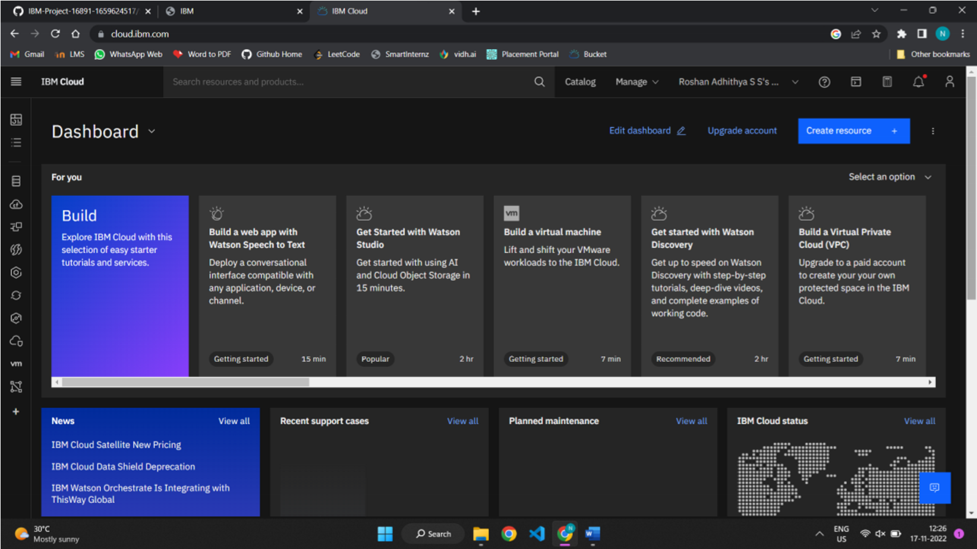

**Step 2.** Search on Container Registry and give get started and follow the steps to install IBM Cloud CLI.

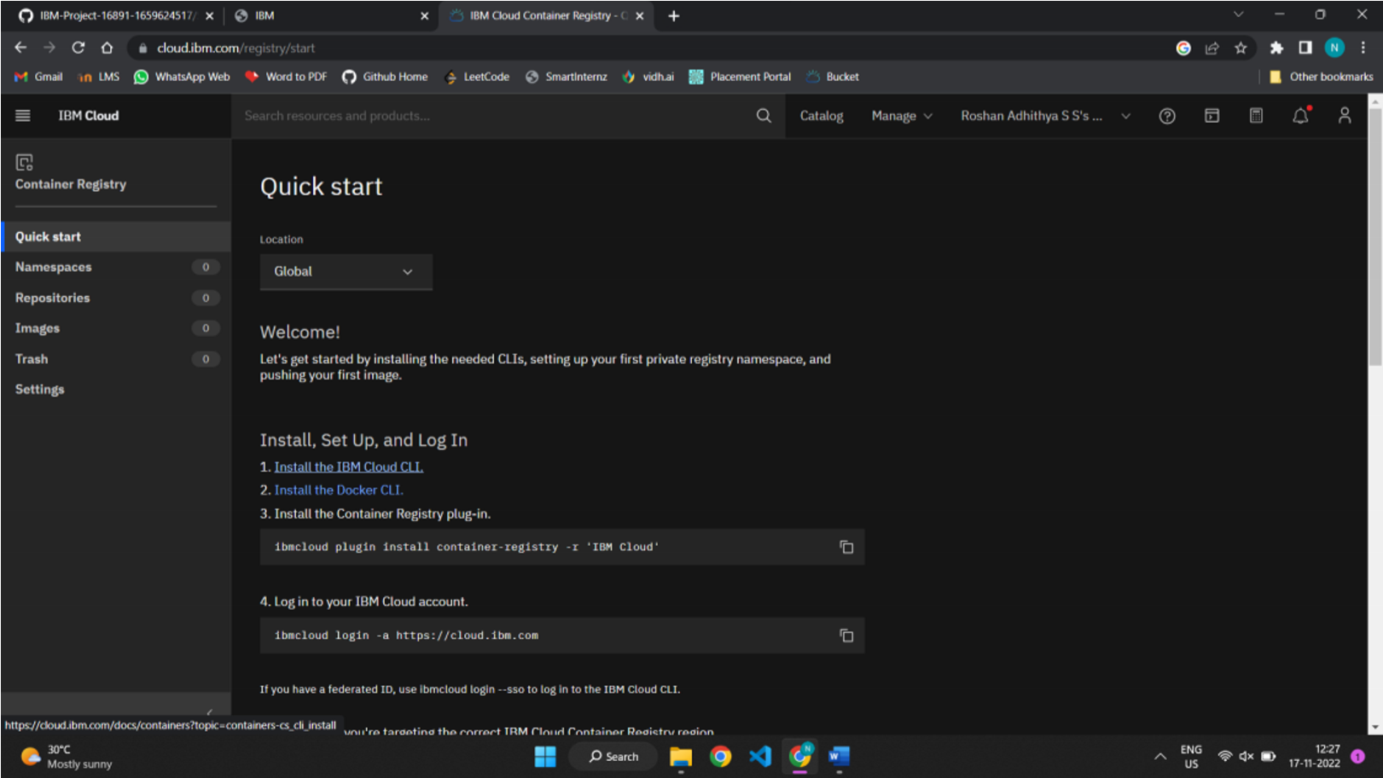

**Step 3**. Download windows 64 bit installer

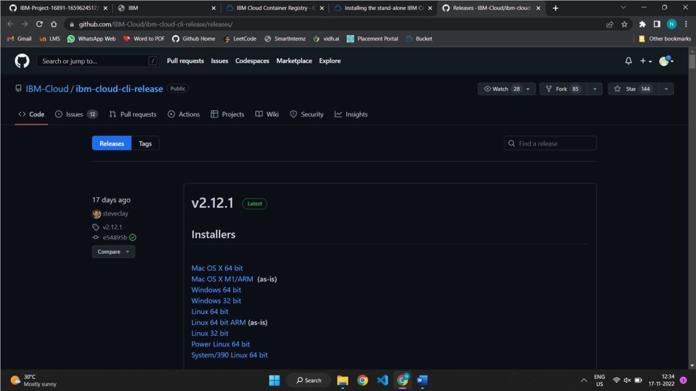

**Step 4.** Open the downloaded .exe file and run it to install IBM Cloud CLI.

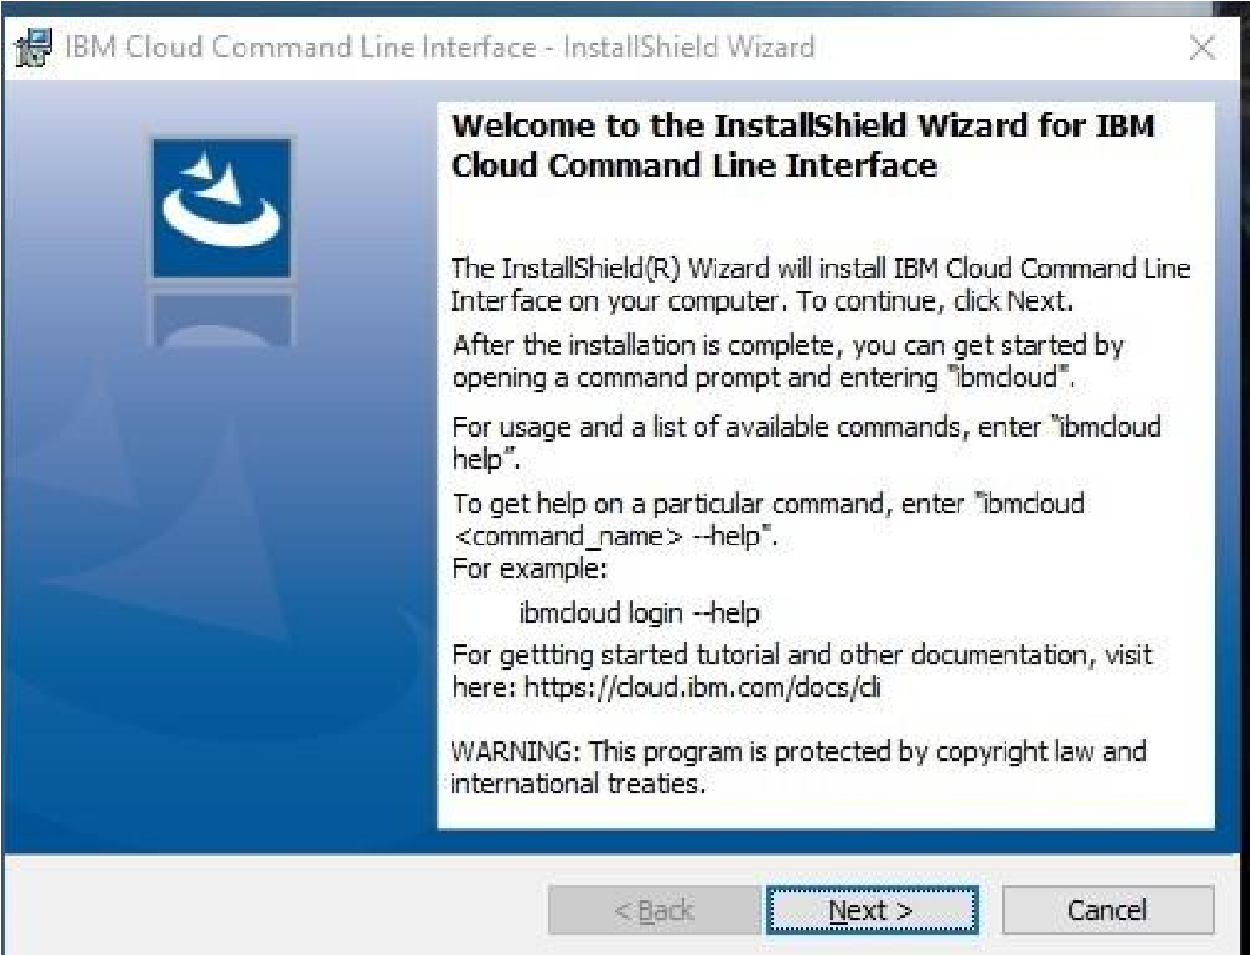

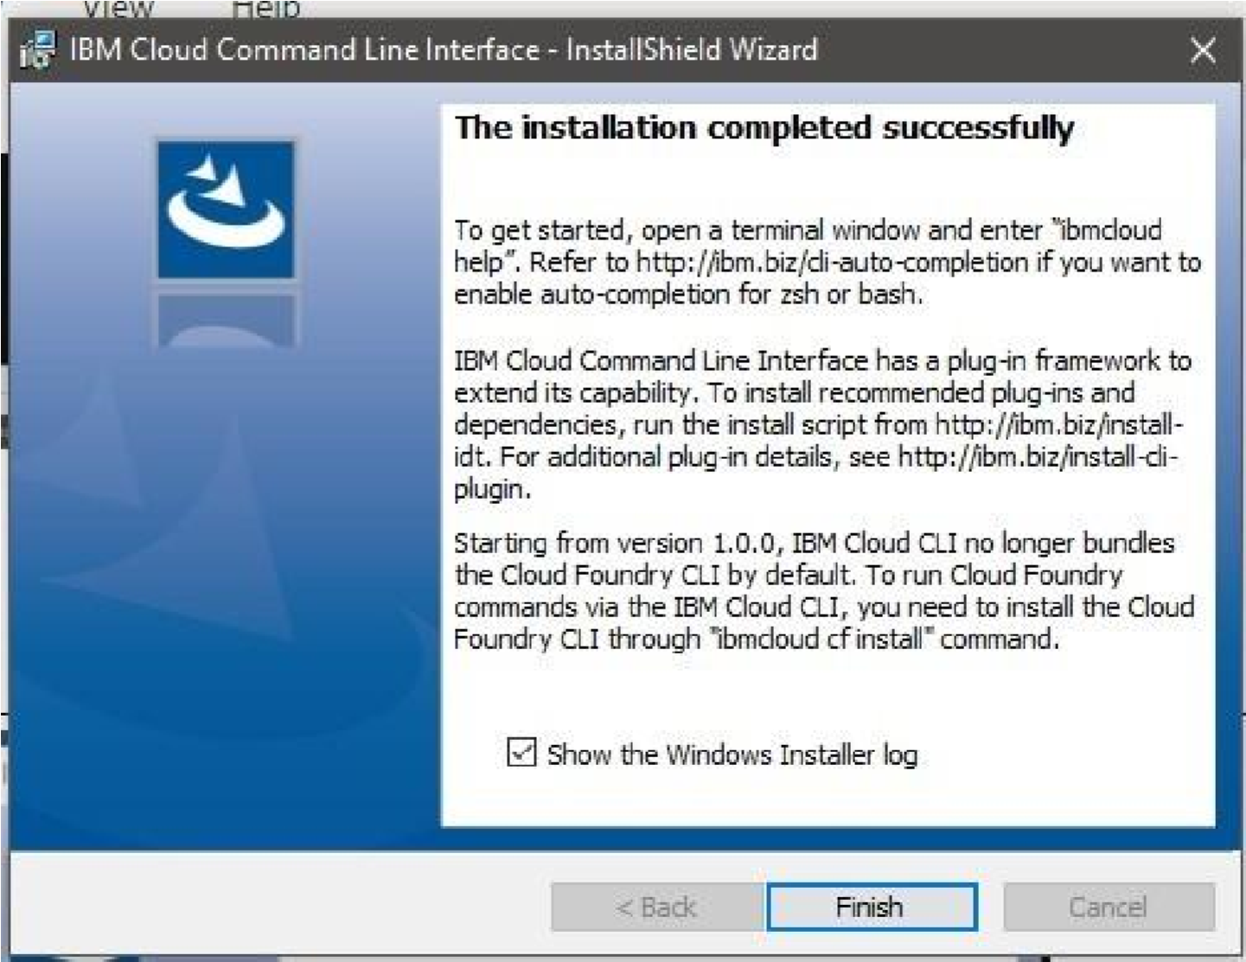

**OUTPUT:**

IBM Cloud CLI is installed successfully